- Problem and Motivation
We study gender bias in static word embeddings (GloVe 6B 300d). Most prior work assumes that gender bias can be represented as a single direction in embedding space and removed by projection.
In this work, we investigate whether gender bias is truly one-dimensional or whether it is distributed across multiple principal components of a gender subspace.
Our approach is to progressively remove principal components derived from gender-definitional word pairs and observe how different bias and geometry metrics respond.

- Experimental Setup
We construct a gender subspace using PCA on difference vectors of definitional word pairs (e.g., he–she, man–woman, king–queen).
We then progressively remove the top k principal components from all word vecto

$${\left(v\right)}^{k}=(I-\sum_{i=1}^{k}{g_{i}g_{i}^{T})v}$$

We evaluate the following metrics:
- Direct Bias (projection-based metric)
- WEAT association score (Cohen’s d)
- Mean vector displacement
- Neighbor stability@10
We test k ∈ {0, 1, 2, 3, 5, 8, 10}.

- Main Observations
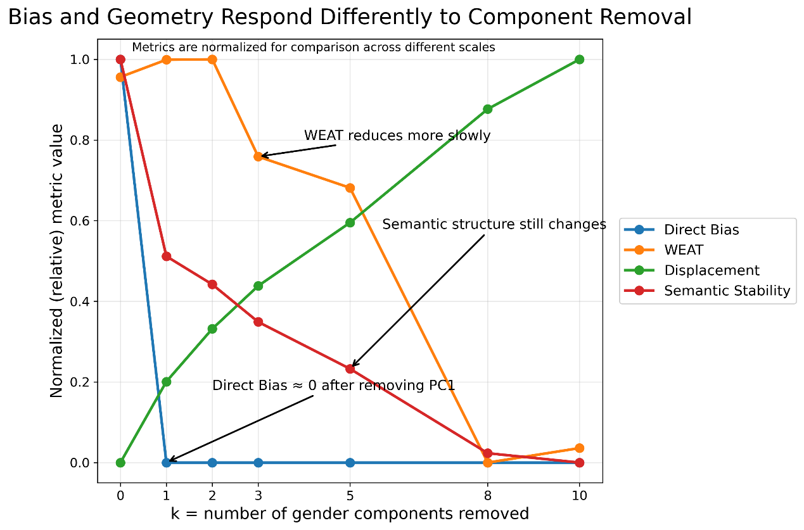
Figure 1. Progressive removal of gender principal components.
Key observations:
- Removing PC1 eliminates Direct Bias almost completely.
- WEAT decreases more gradually.
- Semantic geometry (displacement and neighbor stability) continues to change as more components are removed.

- Mathematical Formulation of Debiasing Operator
We formalize the removal of principal components as a linear projection operation.
Let $v in R^{d}$ be a word embedding vector and let $\left\{ {\left\{g_{i}\right\}}_{\left\{i=1\right\}}^{\left\{k\right\}}\right\}$ be orthonormal principal components derived from the gender subspace. Removing a single principal component $g_{i}$ is defined as:
$$v^{\left\{\left(i\right)\right\}}= \left(I - g_{i}g_{i}^{T}\right)v$$

More generally, removing the first $k$components:
$${\left(v\right)}^{k}=(I-\sum_{i=1}^{k}{g_{i}g_{i}^{T})v}$$
This operator corresponds to projecting vectors onto the orthogonal complement of the subspace spanned by the selected principal components.

- Single Principal Component Ablation
To better understand how bias is distributed across principal components, we perform a single-component ablation study. Instead of removing the top $k$components cumulatively, we remove each component individually:
$$v^{\left\{\left(i\right)\right\}}= \left(I - g_{i}g_{i}^{T}\right)v$$
For i = 1, …. 10 for each modified embedding, we evaluate:
- Direct Bias
- WEAT score
- Mean displacement from the original embedding
- Neighbor stability@10

- Key Results from Principal Component Ablation:
GitHub: https://github.com/AlexeyKresin/embedding-bias-geometry/tree/main/experiments/single%20pc%20ablation
Our results reveal a strong asymmetry between bias removal and geometric distortion:
- PC1 dominates Direct Bias
Removing the first principal component reduces Direct Bias to nearly zero.
- WEAT is not aligned with PC1
The largest reduction in WEAT occurs at higher components (e.g., PC4), indicating that bias is distributed across multiple directions.
- PC1 causes maximal geometric distortion
Removing PC1 results in the largest mean displacement, suggesting it encodes substantial non-bias-related information.
- Higher components produce smaller, more stable changes
Removing PCs beyond PC1 leads to moderate geometric changes while still affecting bias metrics.

- Interpretation
These results suggest that gender bias in word embeddings is not strictly one-dimensional.
While Direct Bias is concentrated in the first principal component, association-based metrics such as WEAT depend on multiple directions in the embedding space.
This indicates a trade-off:
- Removing dominant components (e.g., PC1) effectively reduces bias but introduces significant geometric distortion.
- Removing smaller components leads to less distortion but only partial bias reduction.
This highlights a fundamental tension between fairness and semantic preservation in embedding debiasing. These findings challenge the common assumption that bias can be removed by eliminating a single direction, and instead suggest a more distributed structure of bias in embedding space.

